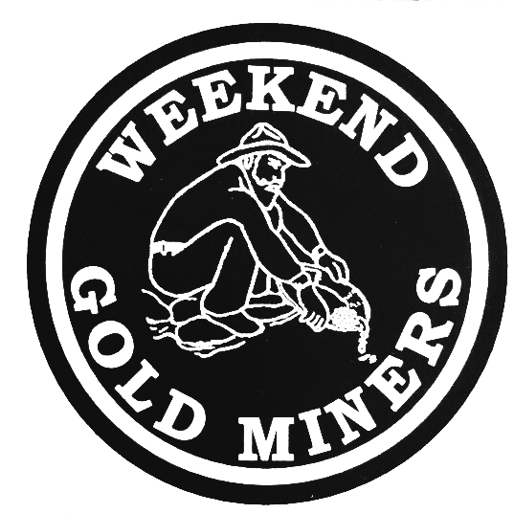 | WEEKEND GOLDMINERS  Newsletter  Prospecting sites in the Heart of Georgia’s Gold Belt
 | Established 1994
Calendar of Events

April 2, 2022:
Metal Detecting Hunt: 12:00 PM
Board meeting: 3:00 PM
General Meeting: 5:00 PM
Held at Auraria Community Center, 4125 Auraria Road, Dawsonville, GA 30534
Do NOT metal detect here any other dates!

April 9, 2022:
Old Fashioned Commons Dig at Turner Property
Bring your prospecting equipment. Pot Luck Lunch.

Check WEGM Website and Facebook group for more updates and announcements.
Officers and Committees

OFFICERSPresident Rodney Kocher 813-924-8403 o2binbed@aol.com
Vice PresidentBarbara Lawson 706-864-1044 / 706-531-4062
lawsonb1947@gmail.comSecretaryHeidi Lung 352-777-0075 Hlung1225@outlook.comTreasurerAnn Nemeth 740-294-1358
rcart4@hotmail.comBOARD OF DIRECTORSMemberRobert Samples 770-374-8026 Samplesr88@gmail.comMemberMemberRodney Lung 352-531-9346
lungster67@yahoo.comMemberCeleste Wilkerson 706-265-5293
armydragonwidow@yahoo.comWEGM AuxMembershipRodney Lung 770-531-9346 weekendgoldminers@yahoo.comNewsletter EditorAnn NemethHuntmasterJohn BurtonWEGM AgentRay Sparks
MAIL DUES TO:
WEGM
P.O. Box 910
Dahlonega, GA 30533

PLEASE INCLUDE YOUR
MEMBER # ON YOUR CHECK

WE ALSO NOW ACCEPT ZELLE PAYMENTS
Send to rcart4@hotmail.com

Drawings

Red ticket door prize:
Silver round #2619 Ray Sparks
Gem book #2533 Bill Quick

Blue tickets
Bag of Ore #2267 Ben Tighe
Bag of ore#3615 Randall Cowart
Bag of ore #3247 Rodney Lung
Nugget #3668 William Simmons

Green tickets
Bag of ore #2267 Ben Tighe
Bag of ore #2854 Mark Nesbitt
Bag of ore #2854 Mark Nesbitt
wheat penny #2619 Ray Sparks
Wheat penny #3615 Dana Cowart
Copper round #3517 Mary Kozak
Nugget #3615 Dana Cowart

Yellow tickets
Bag of ore #3352 Rodney Kocher
Bag of ore #3615 Dana Cowart
Bag of ore #2854 Mark Nesbitt
Nugget # 3668 William Simmons
Copper round #2854 Mark Nesbitt

New Properties Finders Fee

It is the policy of the WEGM to reward its members with a finders fee for locating new properties for the club to lease. The member will be paid $240 or receive credit for $240 in membership dues upon the club approving the lease for club use. The member must act as an agent between the landowner and the WEGM. To receive the finders fee, you must register in writing with the club secretary your intent to begin discussing a proposed lease with the landowner. You cannot receive the finders fee unless registration is complete and the lease is approved by the WEGM.

SALES

The FOR SALE section is free for members only.

Dredge and Highbanker Combo $1300
Contact: Serena Welch (#2466) 706-344-7588

Membership For Sale $1300
Contact: Leona Welch (#3084) 678-523-6116

These are the new WEGM T-shirts for the men and ladies. All shirts are $10.00 ea. There will be a $6.50 shipping and handling charge for each shirt. If you want to place an order please state the color and size of shirt and how many. Send your order to: T-Shirt Order. P.O. Box 910, Dahlonega, Ga. 30533. Make check or money order to Weekend Gold Miners Club.

Ladies Shirt Colors: Pink, Green, Purple and Pink Camo.
Sizes: Small, Med., Large, X-Large and 2X.
Ladies shirts do not have a pocket.

Mens Shirt Colors: Black, Tan, Grey, Hunter Green, Camo
Sizes: Small, Med., Large, X-Large, 2X.
Camo shirts do not have a pocket.

STANDING RULES
No use of alcohol on Association outings.
Smoking will not be permitted at Association meetings or activities unless held in the open air.
Members are expected to adhere to the Association’s Code of Ethics while prospecting or mining
Members are expected to conduct themselves at all times in accordance with the laws of the land and reasonable moral behavior
Violation of Standing Rules will result in disciplinary action as determined by the Executive Board of Directors
The President, Vice-President or their appointed spokesperson(s) are the only people authorized to speak on behalf of the WEGM
Regular monthly meetings will be held on the first Saturday of each month at a scheduled time as stated in the club newsletter and website
Fun must be had by all

WEEKEND GOLD MINERS PROSPECTING CLUB, INC.
GENERAL MEETING -- MARCH 3, 2022
President Rodney Kocher called the March 03, 2022, General meeting to order.
Welcome all members & guest to meeting. New members Brandon & Nikki DeLoach.
Anniversaries for the month March: John & Kim Burton 19 yrs. Congratulations.
The oldest member of the club Judy Woody has passed away.
Motion to approve minutes of the February meeting as printed in the newsletter. Mark Nesbitt #2854 made motion to approve. #2533 Bill Quick seconded the motion. All in favor, motion passed and carried.
Treasurer report given by Ann Nemeth for February 2022.
Beg Bal…. ………...$18,067.73
Income……………..$4,397.14
Disbursed………….$2,584.04
End Bal………….... $19,880.80
Savings account…$895.47
#2854 Mark Nesbitt made motion to approve treasurer report, #2619 Ray Sparks seconded. All in favor, motion passed and carried.
To save club money on postage if you have an email, please fill out form that was included with statements. This way we legally have your permission to send statements on file. Emailing saves instead of bulk mailing. You can also receive statements more often. Any questions regarding your account call Ann Nemeth.
Ann Nemeth purchase laptop and security coverage on her own for this job.
Membership Report: Rodney Lung gave February 2022 report as follows.
New members- 5
Transfers- 0
New members YTD- 9
Last #- 3669
Total new membership fees $500.00
Logo items $0 Total Collected $500.00
#2610 Ray Sparks made motion to accept the February membership report. #2854 Mark Nesbitt second. All in favor, motion passed and carried.
OLD BUSINESS:
Last meeting the club approved locks since locks were lost in the fire. Keys are made & will be mailed out to all members in good standing. Locks changed April 1st.
Last month we talked about Lot signs. Each campsite will have lot number for emergency services. Christine Strickland volunteered her time and materials and has made these signs. These will be placed in front of each site.
Stay in compliance with rules of properties keeping sites neat and clean. Mining equipment out of site when not in use. Allison property enclosed canopies over tents.
NEW BUSINESS:
A special thanks to Randall Cowart for printing up and donating sign in sheets to the club.
The board approved the Quick books at $29.00 a month. This makes statements easier, and treasurer will be able to send monthly statements to the accountant, saving the club money at tax time.
Maintenance on roads. Your concerns about the roads before the gates in need of repair. These are the landowner’s road repairs. The club will address your concerns with them. Also take into fact with the continuous rains has made it difficult to accomplish what needs to be done.
As a part of the clubs non for profit, on March 29th The club will be showing the students at Blackburn school how to pan. It will be in 15-minute segments for over 800 children. The club needs volunteers.
QUESTION & ANSWERS
Members requesting a common dig on April 9th. Bring buckets and shovels it will be an old fashion dig. Bring a dish this will be a potluck.
Thank you all for your help cleaning up
#3615 Randall Cowart made motion to adjourn general meeting. #2854 Mark Nesbitt seconded the motion. Motion passed & carried
Metal Detecting 12pm
Next meeting April 2nd
Board meeting 3:00pm
General meeting 5:00pm
Prepared by Heidi Lung WEGM Secretary




