|  |  |
| --- | --- |
|  | **WEEKEND GOLDMINERS Newsletter**  ***Prospecting sites in the Heart of Georgia’s Gold Belt*** |
| **Established 1994** |

**Calendar of Events**

**June 4, 2022:**

**Board meeting: 3:00 PM**

**General Meeting: 5:00 PM**

**Held at Auraria Community Center, 4125 Auraria Road, Dawsonville, GA 30534**

**Do NOT metal detect here any other dates!**

**July 2, 2022:**

**Special Meeting 1pm**

**Held at Auraria Community Center, 4125 Auraria Road, Dawsonville, GA 30534**

**July 23, 2022:**

**Commons dredge at Allison (details to follow)**

**Check website and WEGM facebook for any updates.**

**Officers and Committees**

|  |  |  |  |
| --- | --- | --- | --- |
| **OFFICERS** | | | |
|  |  | | |
| **President** | **Rodney Kocher 813-924-8403 o2binbed@aol.com** | | |
| **Vice President** | **Barbara Lawson 706-864-1044 / 706-531-4062**  **lawsonb1947@gmail.com** | | |
| **Secretary** | **Heidi Lung 352-777-0075 Hlung1225@outlook.com** | | |
| **Treasurer** | **Ann Nemeth 740-294-1358**  **rcart4@hotmail.com** | | |
|  |  | |  |
| **BOARD OF DIRECTORS** | | | |
| **Member** | | **Robert Samples 770-374-8026 Samplesr88@gmail.com** | |
| **Member** | | **Randall Cowart** | |
| **Member** | | **Rodney Lung 352-531-9346 lungster67@yahoo.com** | |
| **Member** | | **Celeste Wilkerson 706-265-5293**  **armydragonwidow@yahoo.com** | |
|  | |  | |
| **WEGM Aux** | |  | |
| **Membership** | | **Rodney Lung 770-531-9346** weekendgoldminers@yahoo.com | |
| **Newsletter Editor** | | **Ann Nemeth** | |
| **Huntmaster** | | **John Burton** | |
| **WEGM Agent** | | **Ray Sparks** | |

**MAIL DUES TO:**

WEGM  
P.O. Box 910

Dahlonega, GA 30533

**PLEASE INCLUDE YOUR  
MEMBER # ON YOUR CHECK**

**WE ALSO NOW ACCEPT ZELLE PAYMENTS**

**Send to rcart4@hotmail.com**

**Check WEGM Website and Facebook group for more updates and announcements.**

**Drawings**

**Red ticket door prize:**

Silver round #3274 Heidi Lung

**Blue tickets**

Bag of Ore #3615 Randall Cowart

Bag of ore #3044 Ann Nemeth

Nugget #3247 Rodney Lung

**Green tickets**

Bag of ore #3323 Terry Newman

Bag of ore #2854 Mark Nesbitt

Nugget #2854 Mark Nesbitt

2 Lincoln Penny #3247 Rodney Lung

2 Lincoln Penny #3352 Rodney Kocher

**Yellow tickets**

Bag of ore # 3615 Randall Cowart

Bag of ore #3615 Randall Cowart

Nugget #2267 Ben Tighe

Necklace #2854 Mark Nesbitt (donated to new member)

**SALES**

**The FOR SALE section is free for members only.**

Keene 2.5” dredge Model 2604 4hp gx Honda 160 water pump KACI Air compressor Hot water system 20ft suction nozzle with hot water hose. 11 hrs on dredge., Keene dredge sluice box recovery system, Keene 12v super concentrator, Keene blue bowl with bucket clips, Keene large super sucker, Pump seal for Keene 160 pump, New 12x36 Green Miracle Mat, Keene A51A Super mini sluice, Desert Fox Gold panning machine, 4in Screens 20-30-50-100 Mesh,

Keene classifying sieves bucket size 20-30-50-100 Mesh, 2 new spark plugs for Honda motor, 2 gold panning pans, Many other related items. All paperwork and instructions included. $3500 Member #3583 Lawrence Bunnell (803)-210-6414 Call or Text after 6PM

Membership Only #3269 asking $1200 Thomas Email: Hoot_n_holler@bellsouth.net (770)-412-8375

These are the new WEGM T-shirts for the men and ladies. All shirts are $10.00 ea. There will be a $6.50 shipping and handling charge for each shirt. If you want to place an order please state the color and size of shirt and how many. Send your order to: T-Shirt Order. P.O. Box 910, Dahlonega, Ga. 30533. Make check or money order to Weekend Gold Miners Club.

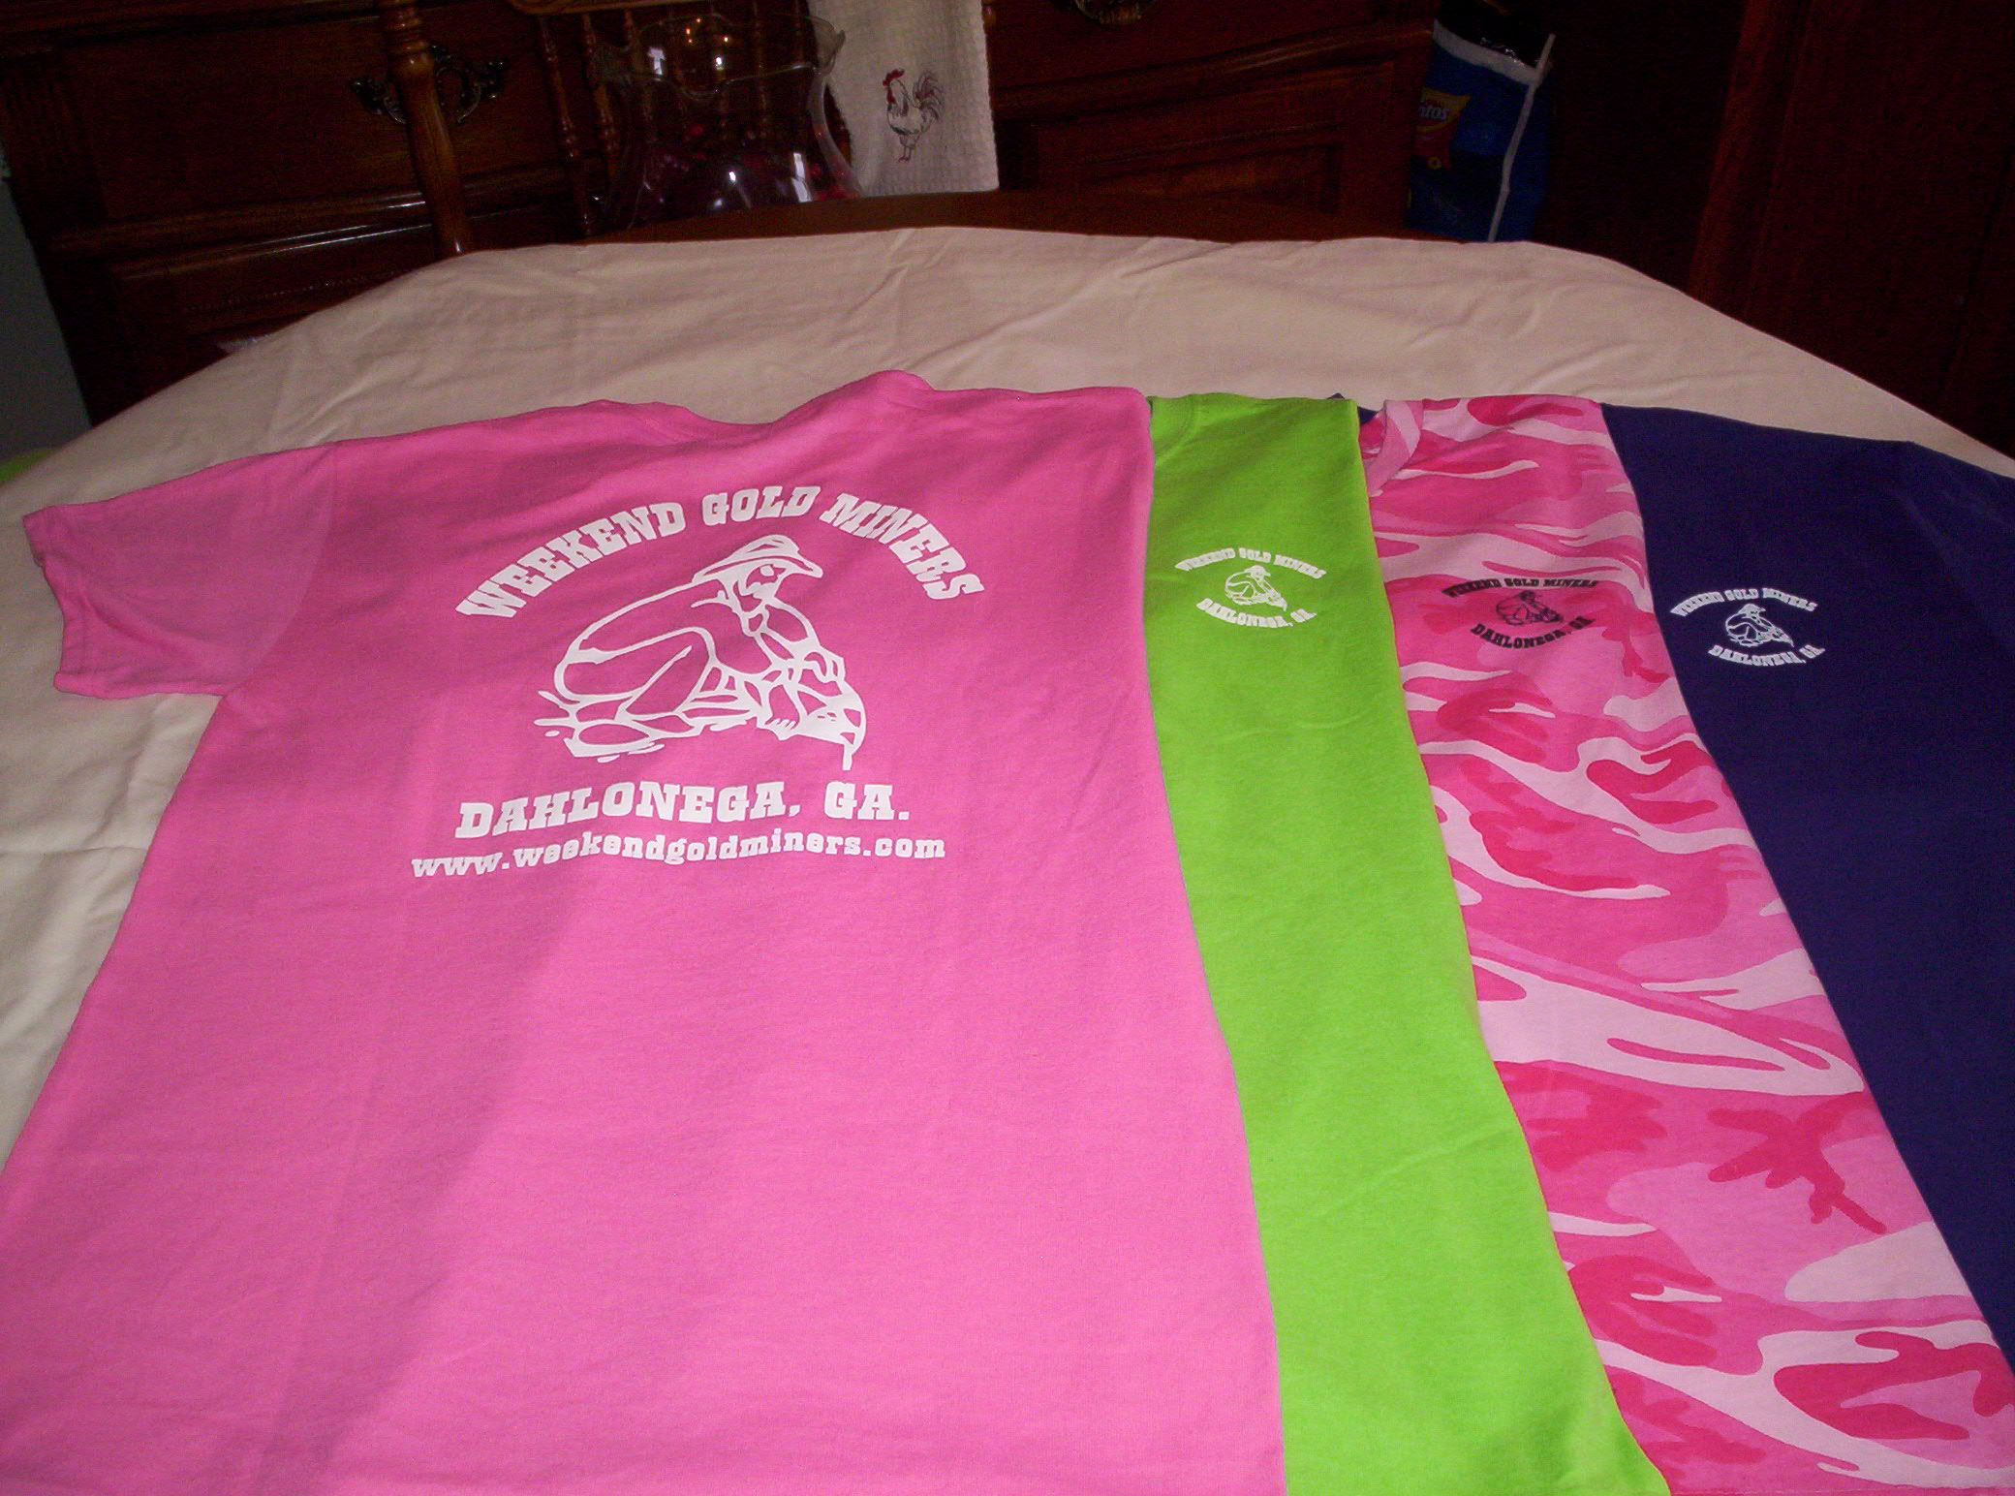

Ladies Shirt Colors: Pink, Green, Purple and Pink Camo.

Sizes: Small, Med., Large, X-Large and 2X.

Ladies shirts do not have a pocket.

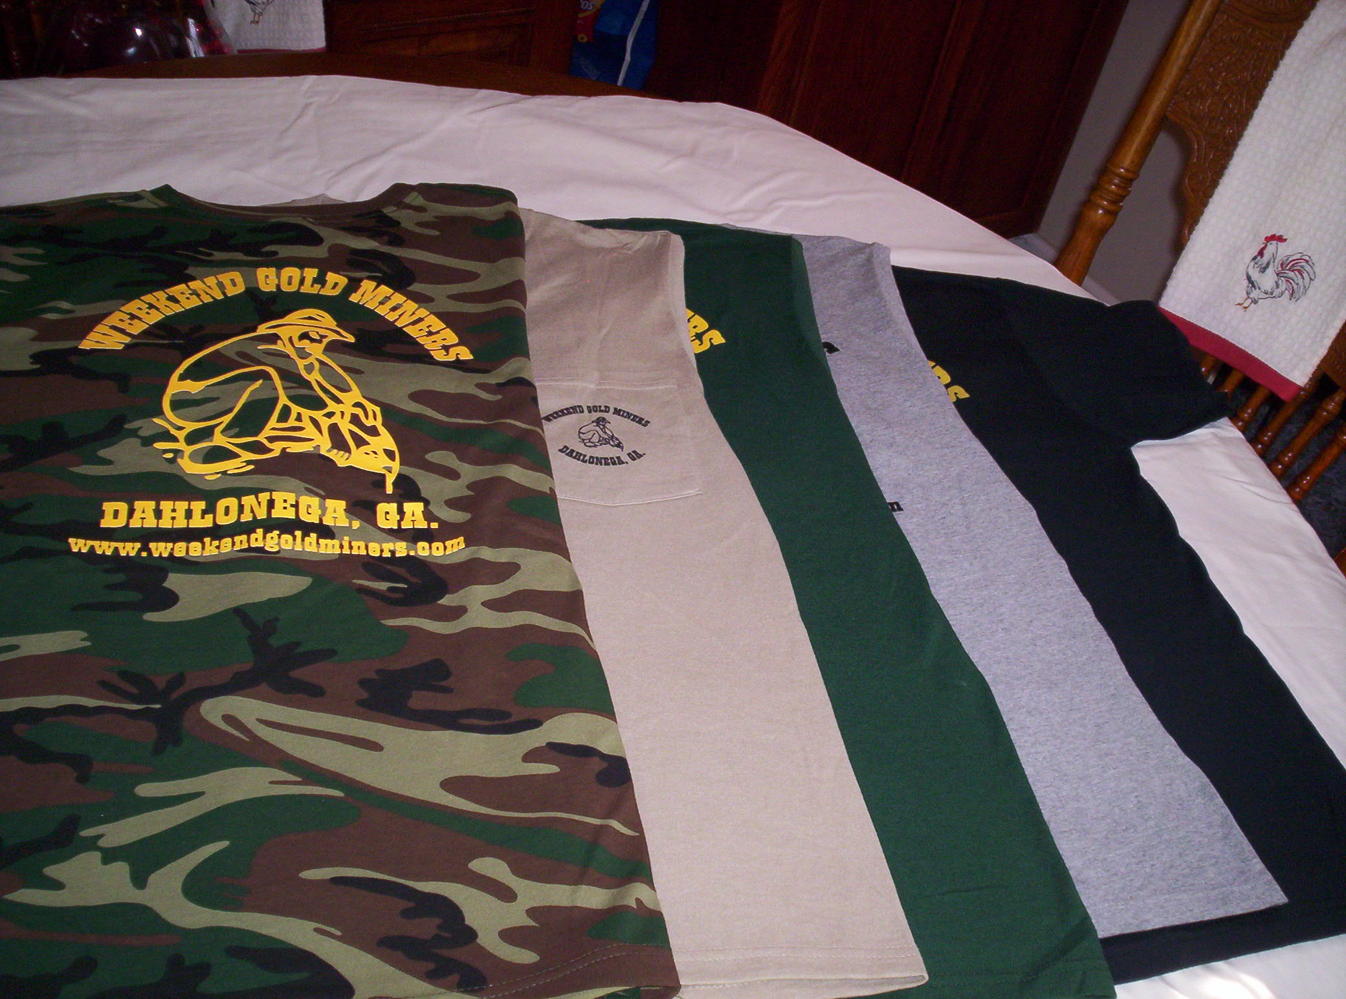

Men’s Shirt Colors: Black, Tan, Grey, Hunter Green, Camo

Sizes: Small, Med., Large, X-Large, 2X.

Camo shirts do not have a pocket.

**STANDING RULES**

1. No use of alcohol on Association outings.
2. Smoking will not be permitted at Association meetings or activities unless held in the open air.
3. Members are expected to adhere to the Association’s Code of Ethics while prospecting or mining
4. Members are expected to conduct themselves at all times in accordance with the laws of the land and reasonable moral behavior
5. Violation of Standing Rules will result in disciplinary action as determined by the Executive Board of Directors
6. The President, Vice-President or their appointed spokesperson(s) are the only people authorized to speak on behalf of the WEGM
7. Regular monthly meetings will be held on the first Saturday of each month at a scheduled time as stated in the club newsletter and website
8. Fun must be had by all

**WEEKEND GOLD MINERS PROSPECTING CLUB, INC.**

**GENERAL MEETING –** **May 7, 2022**

President Rodney Kocher called the May 7, 2022, General meeting to order.

Welcome new members Justin Peppers, Tyron Williams & Jessica Peppers. Lifetime members# 3424 Russell Johnson, # 3679 Charles Brandon Perry No Birthdays or anniversaries.

Happy Mother’s Day, roses were presented to all ladies present.

Condolences to the families of member #1545 Ernie Dunn , Also #1924 David Pearson passed away April 5th.

Motion to approve General meeting as written in the newsletter. #3615 Randall Cowart made motion #3323 Terry Newman second the motion. Motion passed and carried.

This is an explanation of procedure for routine reports: Unless there are any questions, we assume that the motion has been approved. During the meeting stand up and say point of order and we will address the point of order. We cannot move on until the point of order is satisfied. This will be especially important at the special meeting in July.

**Treasurer report given by Ann Nemeth for April 2022:**

Beg Bal…. ………...$31,764.85

Income……………..$7,409.18

Disbursed………….$15,648.67

End Bal…………….. $23,525.36

Savings account…$15,895.59

$15,000.00 was transferred to the savings account was included in the disbursements.

#2533 Bill Quick made motion to approve treasurer report, #3517 Mary Kozak Seconded. Motion passed and carried.

**Membership Report given by Rodney Lung for April 2022:**

New members 10

New members YTD 24

Transfers 0

Total new membership fees $1,080.00

Logo items $0

Last member number issued: #3680 Total Collected $1080.00

#2533 Bill Quick made motion to approve. #3517 Mary Kozak second motion. Motion was passed and carried.

**HUNT MASTER**: John Burton thanked everyone for coming out. We had 6 members for the hunt. This was the last hunt of the season. However, if you are a member you can hunt on your own during meeting times. Special Thank you to John Burton for all he did during the Hunt master season.

**OLD BUISNESS:**

1. T-shirts and hats have been ordered. We will buy more as they are sold.

2.Elections: We need volunteers! Positions open are 2 board member positions, Vice president, treasurer and secretary.

3 Auxiliary yard sale still in the process of an attentive date.

**NEW BUISNESS:**

1.Last month the board appointed Randall Cowart to fill the vacant seat on the board. Hand vote by the membership for approval was taken for his place on the board, 24 in favor 0 nays

2. The price of T-shirts will increase to $15.00 due to increase of shirts and printing.

3.Dredge outing will be at the Blueberry Patch on July 23rd

4. A Special meeting was called for July 2nd 2022. The only items that will be covered will be the Bi-Laws. The only votes at that meeting will be which item will be on the ballot. As procedure a ballot vote will be sent to members in good standing by email, letter or copy can be made from July newsletter.

5.Heidi Lung will be election chairperson. Club needs volunteers for election committee, also to run for board. There are 2 board positions, Vice President, Treasurer and secretary.

**Question and Answers:**

Last meeting it was voted on for the number of visitors and length of stay. Members are to accompany their visitors. Visitors are allowed 2 visits per year, staying no more than 14 days. Should they come once for 3 days and another time for 7 days, that is considered their two visits and then must join in order to revisit properties. Any guest entry to either property is considered as a visit whether they stay or not. A family is considered one guest.

Next meeting June 4, 2022

Board meeting 3:00pm

General meeting 5:00pm

Special Meeting 1PM July 2, 2022

Prepared by Heidi Lung WEGM Secretary