|  |  |
| --- | --- |
|  | **WEEKEND GOLDMINERS Newsletter**  ***Prospecting sites in the Heart of Georgia’s Gold Belt*** |
| **Established 1994** |

**Calendar of Events**

**July 2, 2022:**

**Special meeting: 2:00 PM**

**Board meeting: 3:00 PM**

**General Meeting: 5:00 PM**

**Held at Auraria Community Center, 4125 Auraria Road, Dawsonville, GA 30534**

**Do NOT metal detect here any other dates!**

**Commons Dredge at Allison July 23rd**

**JULY 2, 2022 SPECIAL MEETING AT 2PM**

**\*\*Election of Officers in August\*\***

**Ballot on Last Page. Remember to sign and mail back!!**

**Officers and Committees**

|  |  |  |  |
| --- | --- | --- | --- |
| **OFFICERS** | | | |
|  |  | | |
| **President** | **Rodney Kocher 813-924-8403 o2binbed@aol.com** | | |
| **Vice President** | **Barbara Lawson 706-864-1044 / 706-531-4062**  **lawsonb1947@gmail.com** | | |
| **Secretary** | **Heidi Lung 352-777-0075 Hlung1225@outlook.com** | | |
| **Treasurer** | **Ann Nemeth 740-294-1358**  **rcart4@hotmail.com** | | |
|  |  | |  |
| **BOARD OF DIRECTORS** | | | |
| **Member** | | **Robert Samples 770-374-8026 Samplesr88@gmail.com** | |
| **Member** | | **Randall Cowart** | |
| **Member** | | **Rodney Lung 352-531-9346 lungster67@yahoo.com** | |
| **Member** | | **Celeste Wilkerson 706-265-5293**  **armydragonwidow@yahoo.com** | |
|  | |  | |
| **WEGM Aux** | |  | |
| **Membership** | | **Rodney Lung 770-531-9346 weekendgoldminers@yahoo.com** | |
| **Newsletter Editor** | | **Ann Nemeth** | |
| **Huntmaster** | | **John Burton** | |
| **WEGM Agent** | | **Ray Sparks** | |

**MAIL DUES TO:**

WEGM  
P.O. Box 910

Dahlonega, GA 30533

**PLEASE INCLUDE YOUR  
MEMBER # ON YOUR CHECK**

**WE ALSO NOW ACCEPT ZELLE PAYMENTS**

**Send to rcart4@hotmail.com**

**Check WEGM Website and Facebook group for more updates and announcements.**

**Drawings**

**Red ticket door prize:**

**Silver round # TERRY NEWMAN**

**Blue tickets**

**Bag of Ore # 3615 DANA COWART**

**Bag of ore # 3601 PAUL JONES**

**Bag of ore # 3668 WILLIAM SIMMONS**

**NUGGET #3615 DANA COWART**

**Green tickets**

**Bag of ore # 3353 BILL QUICK**

**Bag of ore # 3615 DANA COWART**

**Bag of ore# 3615 DANA COWART**

**NUGGET #2610 RAY SPARKS**

**Yellow tickets**

***BAG OF ORE #2854 MARK NESBITT***

***BAG OF ORE #3690 JUSTIN PEPPERS***

***BAG OF ORE #2854 MARK NESBITT***

***NUGGET #2325 MICHELLE WINGER***

**From The Desk of Vice President Barbara Lawson**

**I can see so much improvement in our club. Yes, mistakes have been made, but they also have been corrected too.**

**We were on the bottom, but now we are going UP. We will keep going up, by all the good work people have done.**

**Thanks to Ann, Heidi, and the board of directors, we are coming back. -- Also to the members that have had a positive attitude.**

**As the old saying goes “We Are Back”**

**WEGM is coming back. Think positive—NOT negative.**

**God Bless All!**

**Barbara Lawson**

**SALES**

**The FOR-SALE section is free for members only.**

**MEMBERSHIPS FOR SALE:**

**#2197 RONALD TRACY 318-455-5612**

**TRACYRONJ@AOL.COM $1000.00**

**#1940 WILLIAM ROSE 864-414-5062**

**HARRYROSE11@HOTMAIL.COM $750.00**

These are the new WEGM T-shirts for the men and ladies. All shirts are $15.00 ea. There will be a $6.50 shipping and handling charge for each shirt. If you want to place an order please state the color and size of shirt and how many. Send your order to: T-Shirt Order. P.O. Box 910, Dahlonega, Ga. 30533. Make check or money order to Weekend Gold Miners Club.

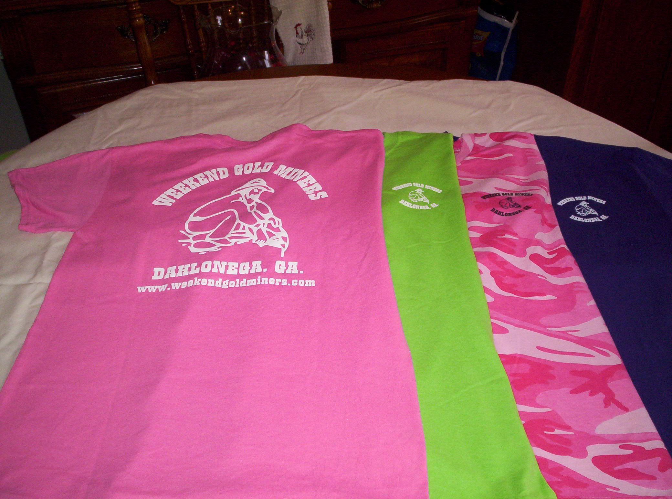

Ladies Shirt Colors: Pink, Green, Purple and Pink Camo.

Sizes: Small, Med., Large, X-Large and 2X.

Ladies shirts do not have a pocket.

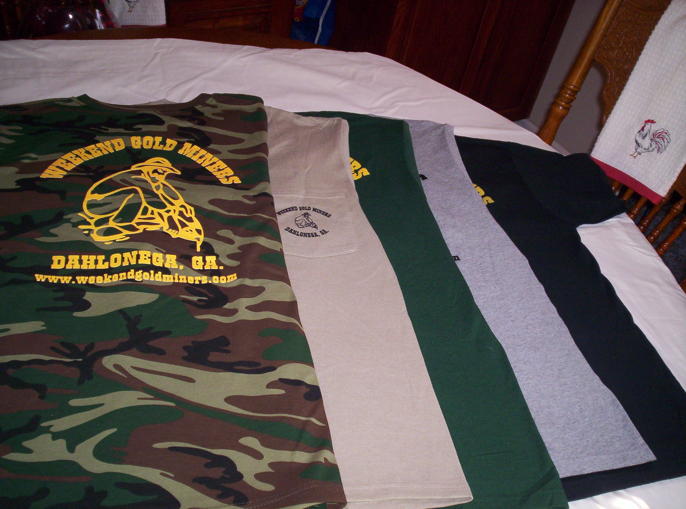

Men’s Shirt Colors: Black, Tan, Grey, Hunter Green, Camo

Sizes: Small, Med., Large, X-Large, 2X.

Camo shirts do not have a pocket.

**STANDING RULES**

1. No use of alcohol on Association outings.
2. Smoking will not be permitted at Association meetings or activities unless held in the open air.
3. Members are expected to adhere to the Association’s Code of Ethics while prospecting or mining
4. Members are expected to conduct themselves at all times in accordance with the laws of the land and reasonable moral behavior
5. Violation of Standing Rules will result in disciplinary action as determined by the Executive Board of Directors
6. The President, Vice-President or their appointed spokesperson(s) are the only people authorized to speak on behalf of the WEGM
7. Regular monthly meetings will be held on the first Saturday of each month at a scheduled time as stated in the club newsletter and website
8. Fun must be had by all

WEEKEND GOLD MINERS PROSPECTING CLUB, INC.

**GENERAL MEETING –** June 4th,2022

President Rodney Kocher called the June 04, 2022, General meeting to order. Welcome all members to the meeting. Condolence to the family of Rodger Hicks passed June 28th at 91yrs old. Birthdays for June #1290 Joyce Conner 6/6

Motion to approve minutes of May meeting as printed in the newsletter. Mark Nesbitt #2854 made motion to approve. #2610 Ray Sparks seconded the motion. All in favor, motion passed and carried.

**Treasurer report** given by Ann Nemeth for May 2022.

Beg Bal…. ………...$23,525.59

Income……………..$5,642.20

Disbursed………….$1,517.33

End Bal…………….. $27,649.47

Savings account…$15,895.73

It was approved Quick books for 29.00 a month. There have been glitches in that, going from the old system to new, Ann has requested a refund. #2890Barbara Lawson made motion to approve treasurer report, #3323 Terry Newman seconded the motion. All in favor, motion passed and carried.

**Membership Report:** Rodney Lung gave May report as follows.

New members 5

New members YTD 29

Transfers 0

Last number issued 3690

Total new membership fees $500.00

Logo items $0

Keys $20.00 Total Collected $520.00

Expense $22.71 for postage

#2890 Barbara Lawson made motion to accept the May membership report. #2854 Mark Nesbitt second. All in favor, motion passed and carried.

**OLD BUISNESS**.

New hats and shirts are in. We have tank top and large sizes. This was a minimum order; we will order more as they sell. The price has gone up to $15.00 due to increase of shirts and printing.

Ongoing for August we have we have approximately 12 days before ballots have to go out. Robert Samples is a board member running, Randall Cowart is a board member appointed last month who also is running. If anyone is interested in running for the board, Vice president , Treasure & Secretary get your name in so it can be put on the ballot. There will also be a write in space for each position open. Heidi has volunteered to election committee chairperson, anyone who can give her a hand with that will be appreciated.

The way it has been done before we didn’t know Georgia is one of the states that excepts Email as written notice. Those who are getting a newsletter by mail will get a ballot with it. Everyone else who get the newsletter by email there will be a ballot attached to that and can be printed off and mailed in. We will post the address and P.O Box to send ballot to. It is a separate P.O Box for ballots. There will be ballots available here the night of election. What this is doing by using email which is a recognized form of mail instead of mailing to every member every month is saving 1,160.00 a month. Saving the club thousands each year.

**NEW BUISNESS**

Common Dredge is July 23rd at Allison’s Blueberry patch. It is open to the public Bring a cover dish to share.

The purposed budget has been approved. we are now on the calendar year now for the accounting for IRS instead of fiscal year of August to August. This helps cut down the price of continuous book examination by the CPA we are required every year. Part of the changes are why we are doing the special meeting July 2nd at 2PM is to do the bylaw change of the annual meeting from August to November. Ballots will be counted at the August which is the normal annual meeting and the election. If ballots come back approved instead of taking office that day, they will take office January, first this way it shifts to calendar year. Special meeting Ballots will be counted at the August Annual meeting and will have the election meeting & ballots as well.

Rodney Kocher and Ann Nemeth will not be at the August meeting. Dana Cowart volunteered to do the food for August.

**Questions & answers**

Yard Sale, we are checking to see dates available for the club house. We originally planned to do it this month, but the owner of the building had just gotten out of the hospital and wasn’t available. Club is checking into dates or possibly doing it on a meeting date. No other questions?

#2890 Barbara Lawson made motion to adjourn general meeting. #Ray Sparks seconded the motion. All in favor. Motion passed & carried

Next Meeting: July 2nd 2022

Special meeting: 2:00pm

Board meeting 3:00pm

General meeting 5:00pm

Prepared by Heidi Lung WEGM Secretary

**Weekend Gold Miners Prospecting Club, Inc**

**Absentee Ballot**

**August 6,2022**

**Office Of Vice President**

____________ 1. #2533 BILL QUICK

WRITE IN____________

**Office of Treasure: (must turn in resume to qualify)**

_____________ 1. #Ann Nemeth

Write in ____________

**Office of Secretary: (must turn in a resume to qualify)**

WRITE IN ____________

POSITION OF BOARD MEMBER **(SELECT TWO CANDIDIATES)**

_______________1. # 3615 Randall Cowart

_______________ 2. #0859 Robert Sample

_______________ 3. #3641 Michael Sannuti

WRITE IN ___________________

WRITE IN ___________________

MEMBERS MUST BE IN GOOD STANDING TO CAST A VOTE

MEMBER NUMBER _________MEMBER NAME____________________________

BALLOT MUST BE SIGNED TO BE VALID

SIGNATURE_____________________________________DATE____________

**MAIL TO: PO BOX 1663**

**DAHLONEGA, GA 30533**