|  |  |
| --- | --- |
|  | **WEEKEND GOLDMINERS Newsletter**  ***Prospecting sites in the Heart of Georgia’s Gold Belt*** |
| **Established 1994** |

**Calendar of Events**

**AUGUST 6TH, 2022:**

**ELECTION**

**Board meeting: 3:00 PM**

**General Meeting: 5:00 PM**

**Held at Auraria Community Center, 4125 Auraria Road, Dawsonville, GA 30534**

**Do NOT metal detect here any other dates!**

**Commons Dredge at Allison July 23rd,9AM**

**\*\*Election of Officers in August\*\***

**Ballot on Last Page. Remember to sign and mail back!!**

**Officers and Committees**

|  |  |  |  |
| --- | --- | --- | --- |
| **OFFICERS** | | | |
|  |  | | |
| **President** | **Rodney Kocher 813-924-8403 o2binbed@aol.com** | | |
| **Vice President** | **Barbara Lawson 706-864-1044 / 706-531-4062**  **lawsonb1947@gmail.com** | | |
| **Secretary** | **Heidi Lung 352-777-0075 Hlung1225@outlook.com** | | |
| **Treasurer** | **Ann Nemeth 740-294-1358**  **rcart4@hotmail.com** | | |
|  |  | |  |
| **BOARD OF DIRECTORS** | | | |
| **Member** | | **Robert Samples 770-374-8026 Samplesr88@gmail.com** | |
| **Member** | | **Randall Cowart** | |
| **Member** | | **Rodney Lung 352-531-9346 lungster67@yahoo.com** | |
| **Member** | | **Celeste Wilkerson 706-265-5293**  **armydragonwidow@yahoo.com** | |
|  | |  | |
| **WEGM Aux** | |  | |
| **Membership** | | **Rodney Lung 770-531-9346 weekendgoldminers@yahoo.com** | |
| **Newsletter Editor** | | **Ann Nemeth** | |
| **Hunt master** | | **John Burton** | |
| **WEGM Agent** | | **Ray Sparks** | |

**MAIL DUES TO:**

WEGM  
P.O. Box 910

Dahlonega, GA 30533

**PLEASE INCLUDE YOUR  
MEMBER # ON YOUR CHECK**

**WE ALSO NOW ACCEPT ZELLE PAYMENTS**

**Send to rcart4@hotmail.com**

**Check WEGM Website and Facebook group for more updates and announcements.**

**Drawings**

**Red ticket door prize:**

**Silver round # 2533 Bill Quick**

**Blue tickets**

**Bag of Ore # 3352 Rodney Kocher**

**Bag of ore # 2980 Barbara Lawson**

**Bag of ore # Mary Kozak**

**NUGGET #3665 Owen Simmons**

**Green tickets**

**Bag of ore # 3665 Owen Simmons**

**Bag of ore # 3517 Mary Kozak**

**Bag of ore# 3665 Owen Simmons**

**NUGGET # 1963 Rich Hickman**

**Yellow tickets**

***BAG OF ORE #Lee Formby***

***BAG OF ORE # 3665 Owen Simmons***

***BAG OF ORE #2342 Celeste Wilkerson***

***NUGGET #1963 Rick Hickman***

**FOR SALE**

**The FOR-SALE section is free for members only.**

**MEMBERSHIPS FOR SALE:**

**# 3263 Thomas Smith 812-798-7327, email tjsmith5761@gmail.com $500.00**

These are the new WEGM T-shirts for the men and ladies. All shirts are $15.00 ea. There will be a $6.50 shipping and handling charge for each shirt. If you want to place an order please state the color and size of shirt and how many. Send your order to: T-Shirt Order. P.O. Box 910, Dahlonega, Ga. 30533. Make check or money order to Weekend Gold Miners Club.

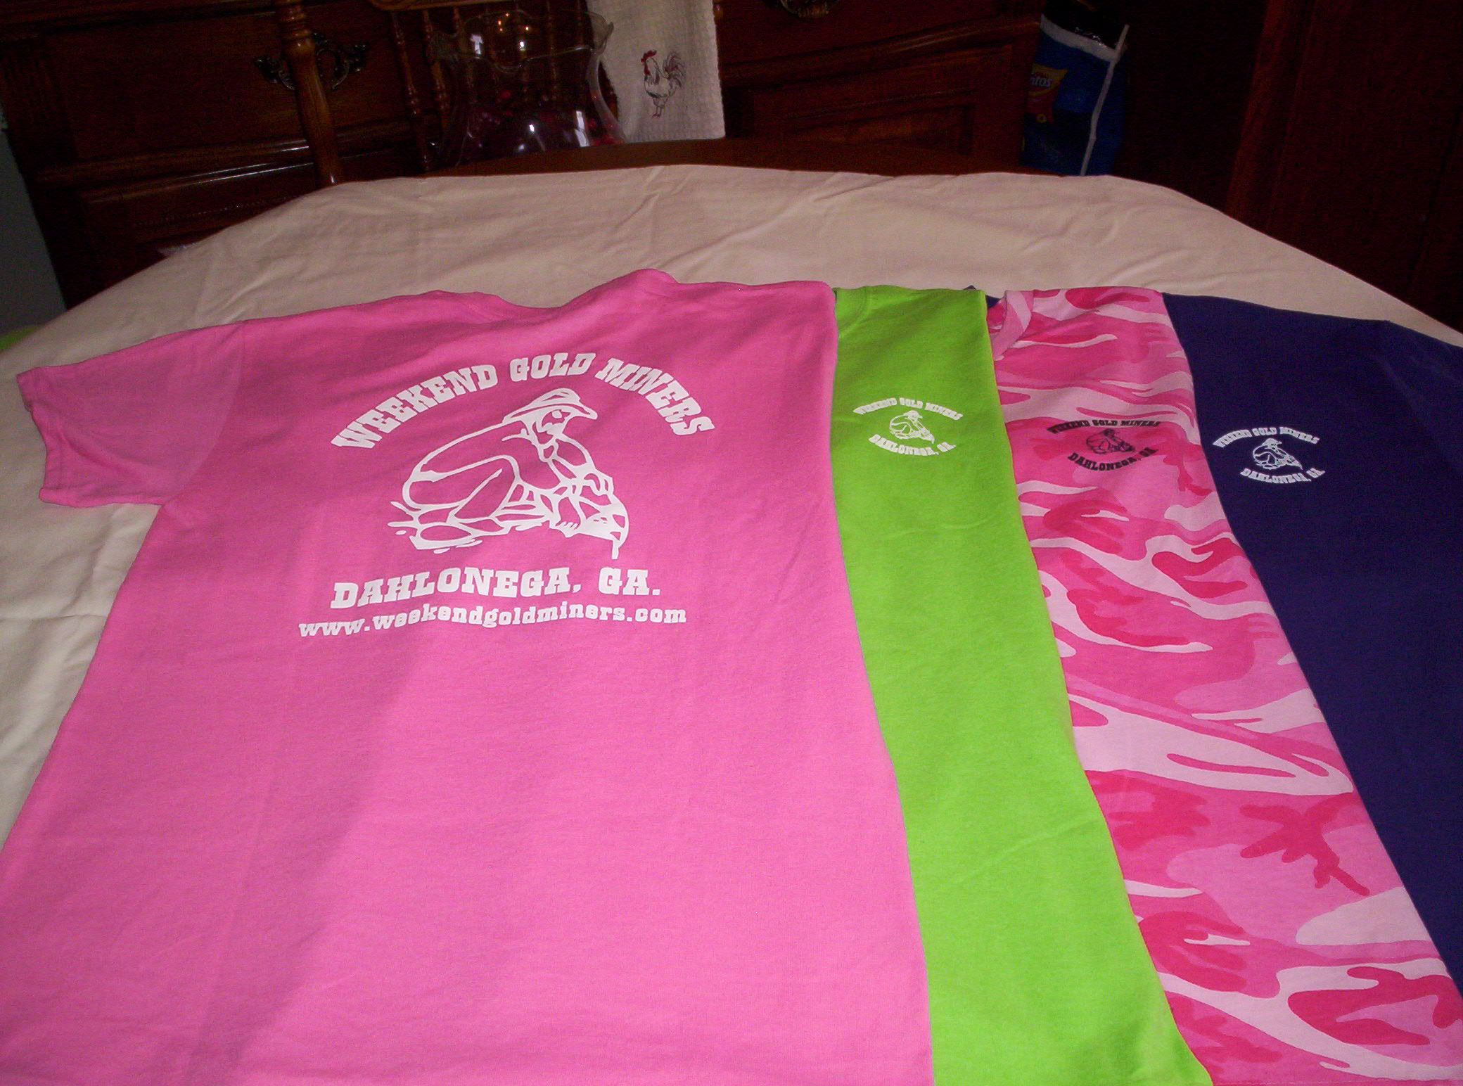

Ladies Shirt Colors: Pink, Green, Purple and Pink Camo.

Sizes: Small, Med., Large, X-Large and 2X.

Ladies shirts do not have a pocket.

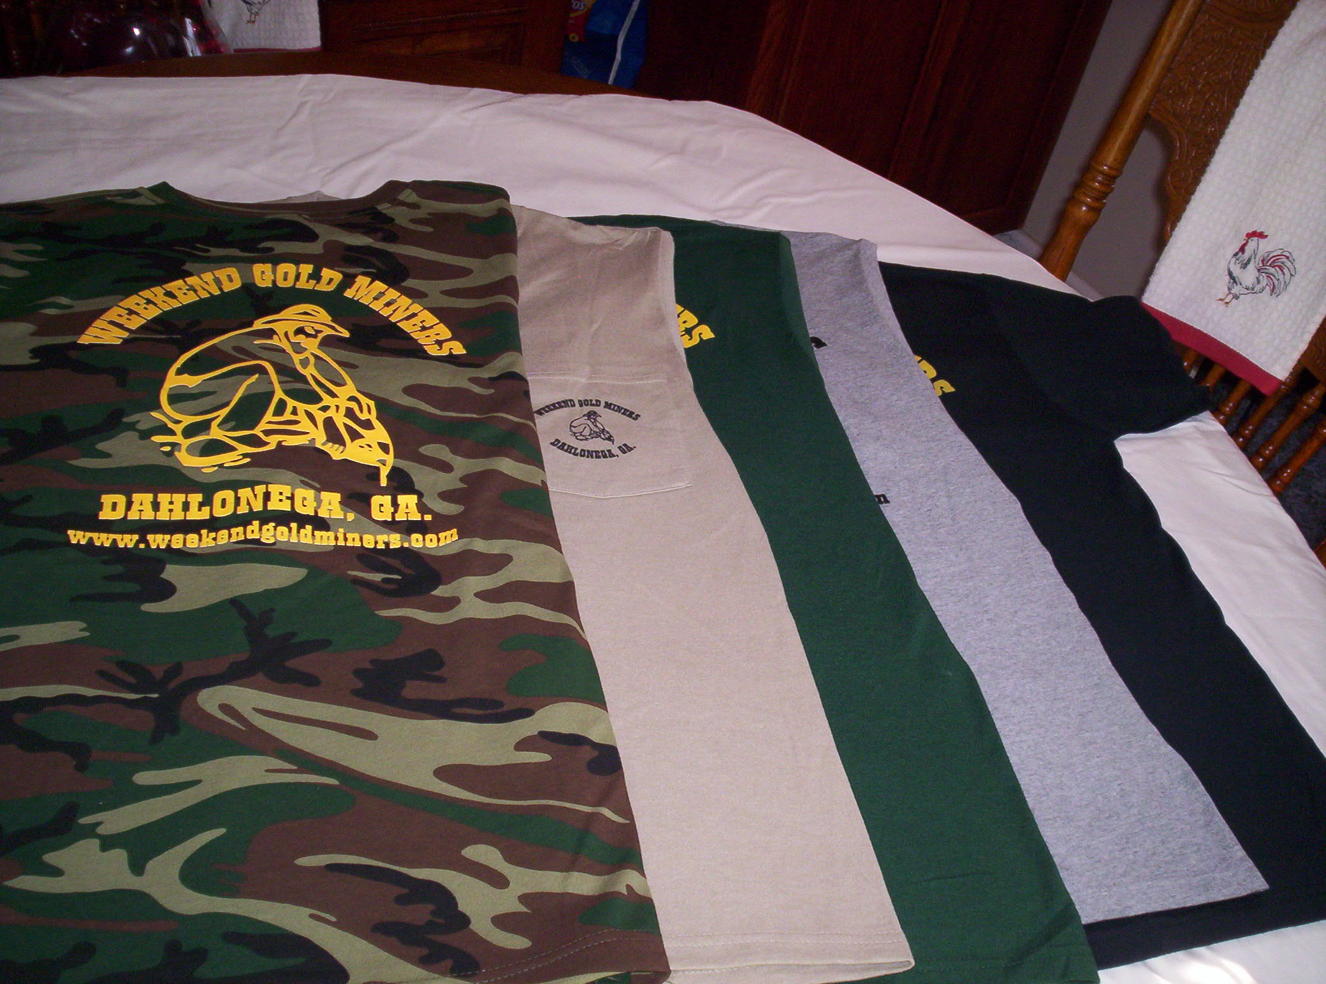

Men’s Shirt Colors: Black, Tan, Grey, Hunter Green, Camo

Sizes: Small, Med., Large, X-Large, 2X.

Camo shirts do not have a pocket.

**STANDING RULES**

1. No use of alcohol on Association outings.
2. Smoking will not be permitted at Association meetings or activities unless held in the open air.
3. Members are expected to adhere to the Association’s Code of Ethics while prospecting or mining
4. Members are expected to conduct themselves at all times in accordance with the laws of the land and reasonable moral behavior
5. Violation of Standing Rules will result in disciplinary action as determined by the Executive Board of Directors
6. The President, Vice-President or their appointed spokesperson(s) are the only people authorized to speak on behalf of the WEGM
7. Regular monthly meetings will be held on the first Saturday of each month at a scheduled time as stated in the club newsletter and website
8. Fun must be had by all

WEEKEND GOLD MINERS PROSPECTING CLUB, INC.

**GENERAL MEETING –** JULY 02,2022

President Rodney Kocher called the JULY02, 2022, General meeting to order. Welcome all members to the meeting.

Birthdays for July 3247 Heidi Lung 7/1, #3555 Harris Seabolt 7/13, Johnny Crumley HAPPY BIRTHDAY Anniversaries;2342 Celeste &Henry Wilkerson 32yrs on 7/15, Prayers for Brenda Shed shes is in hospital with a broken hip.

Motion to approve minutes of June meeting as printed in the newsletter. #2610 Ray Sparks made motion to approve. #3517 Mary Kozak seconded the motion. All in favor, motion passed and carried.

**Treasurer report** given by Ann Nemeth for June 2022.

Beg Bal…. ………...$27,649.47

Income……………..$3,354.00

Disbursed………….$1,014.55

End Bal…………….. $29,988.92

Savings account…$15,895.86

Terry Newman made motion to approve treasure report, #2610 ray sparks seconded. All in favor, motion passed and carried.

**Membership Report:** Rodney Lung gave May report as follows.

New members 2

New members YTD 33

Transfers 02

Last number issued 3695

Total new membership fees $200.00

Logo items $75.00

Tranfer fees $120.00 Total Collected $520.00

Robert Sample made motion to accept the June membership report. #2342 Celeste Wilkerson second. All in favor, motion passed and carried.

**OLD BUISNESS**.

We just completed the Special meeting. There were twelve different changes to the Bylaws. All but one was approved. Those were voted on are to be on the ballot for the membership to approve. The ballot will be attached to the newsletter & sent out. This ballot will also be counted first at the August meeting.

Dredge common is set for July 23 at 9:00am at Allison Blueberry Patch. Bring your chairs and covered dish to share. We will do hamburgers and hotdogs.

Ballots are out for elections. Please be sure to mail them back so your vote can be counted at the August meeting. Part of the items the club had in the Special meeting is the club will have the elections in August but the newly elected will not take office until January. Presently the annual meeting is in August a vote to move the annual meeting to November. This way the new Board members have time to transition, taking office first meeting in January if approved on ballot.

Picnic will be September 3rd held on Turner property. No bounce house this year but, we will have the gem mining for the children. It will be potluck; the club will provide will have hamburgers and hotdogs. Please bring a covered dish to share. The canopy was replaced three years ago but, was taken down since it had holes in it from fallen branches. They were put in storage & lost in the fire, if you have a canopy the club can use for the day if would be appreciated. A few months ago, it was voted on for a metal roof instead of replacing canopies every two years at $600.00 each. Lee Dewitt said he had some tin to donate, he only has enough to cover one of the canopies. If anyone has any tin available, we need to get the second section covered.

**NEW BUISNESS**

It was approved to pay CPA proposed fee of $600.00 to clean up quick books and 1,300.00 for taxes. The club doesn’t pay taxes, but the club still must file. In our bylaws we are required to review taxes in our books by the CPA .With the CPA doing this $600.00 change for the club, since they have already done the taxes, we don’t have to have the review. The 600.00 change being part of that we won’t have the review we had the last 4-5 yrs. It will cost the club $600.00 and 1,300.00 for taxes verses 4,000.00 to 5,000.00 It cost us before. In the future it will easier on the treasures side and cheaper for the club in the long run.

August meeting there will be ballots from the Special meeting and ballots for the election to be counted. We will need volunteers to help count ballots, generally there are three for that, two people to observe. Heidi Lung is the election & ballot chairman; she takes charge of the meeting at that point. She will need volunteers. Results will be posted in the newsletter. Mail Special meeting Ballots back to PO Box 1663 Dahlonega Georgia, 30533

Red door prize ticket has been the silver round. This meeting is the last silver round. Are we to continue that or replace it with something different? Ray Sparks looked it up, to replace silver rounds they are 40.00 each with $5.00 shipping. He suggested 2021 Silver Eagles which is one ounce of silver, twenty-four of them with free shipping will cost $479.52 which will cover the next 2yrs. We can get less but the price is higher. # 2533 Bill Quick made motion to purchase the silver eagles in place of silver rounds. #1900 Nancy Healy seconded the motion. All in favor, motion carried.

**Questions & answers**

Harris Seabolt asked about replacing storage unit. A discussion was held about getting a Conex. Rodney Kocher will look into prices.

Next Meeting: Aug 6th, 2022

Board meeting 3:00pm

General meeting 5:00pm

Prepared by Heidi Lung WEGM Secretary