WEEKEND GOLDMINERS
Newsletter

Prospecting sites in the Heart of Georgia’s Gold Belt
Established 1994
Calendar of Events
SEPT 3rd, 2022:
Annual Picnic- September 3, 2022
Will be Held at Turner Property, 804 Blackburn Road, Dawsonville, GA 30534
Board Meeting: 12PM
Will start serving at 1:00 P.M.
Terry Wilman is making pulled pork and chicken – Please bring a covered
Dish BRING SOMETHING BESIDES JUST YOURSELF!!
General Meeting will start at 3:00 P.M.
End of year Raffles around 4:00 P.M.
Bring a chair
CLEAN-UP WILL BE AUGUST 27TH ONLY ATTEND IF YOU CAN WORK…BRING GLOVES AND BATTERY TOOLS WE WILL BE PUTTING TIN ON FRAMES
Officers and Committees

OFFICERS
President | Rodney Kocher 813-924-8403 o2binbed@aol.com
Vice President | Barbara Lawson 706-864-1044 / 706-531-4062  lawsonb1947@gmail.com
Secretary | Heidi Lung 352-777-0075 Hlung1225@outlook.com
Treasurer | Ann Nemeth 740-294-1358  rcart4@hotmail.com
BOARD OF DIRECTORS
Member |  | Robert Samples 770-374-8026 Samplesr88@gmail.com
Member |  | Randall Cowart
Member |  | Rodney Lung 352-531-9346  lungster67@yahoo.com
Member |  | Celeste Wilkerson 706-265-5293  armydragonwidow@yahoo.com
WEGM Aux
Membership |  | Rodney Lung 770-531-9346 weekendgoldminers@yahoo.com
Newsletter Editor |  | Ann Nemeth
Hunt master |  | John Burton
WEGM Agent |  | Ray Sparks
MAIL DUES TO:
WEGM
P.O. Box 910
Dahlonega, GA 30533

PLEASE INCLUDE YOUR
MEMBER # ON YOUR CHECK

WE ALSO NOW ACCEPT ZELLE PAYMENTS
Send to rcart4@hotmail.com

Check WEGM Website and Facebook group for more updates and announcements.

Drawings

Red ticket door prize:
Silver round #3668 William Simmons

Blue tickets
Bag of Ore # 2854 Mark Nesbitt
Bag of ore # 2845 Terry Willman
Bag of ore # 3668 William Simmons
NUGGET # 2533 Bill Quick

Green tickets
Bag of ore # 3668 William Simmons
Bag of ore # Barbara Lawson
Bag of ore# Rodney Lung
NUGGET # Barbara Lawson

Yellow tickets
BAG OF ORE # Rodney Lung
BAG OF ORE # Christine Strickland
BAG OF ORE # Barbara Lawson
NUGGET Rodney Lung

NOTE WE WILL CLEAN UP PICNIC AREA AND BE PUTTING TIN ON FRAMES ……. THERE WILL NOT BE ROOM FOR ANYONE THAT CANNOT WORK DUE TO LIABILITY THAT SOMEONE COULD GET HURT ……..
I WILL BE SERVING LUNCH TO THE PEOPLE THAT ARE WORKING ……PLEASE IF YOU ARE NOT ABLE TO USE A POWER TOOL OR WALK AROUND PICKING UP TRASH OR LIFT OVER YOUR HEAD PLEASE DON’T ATTEND THIS…..

These are the new WEGM T-shirts for the men and ladies. All shirts are $15.00 ea. There will be a $6.50 shipping and handling charge for each shirt. If you want to place an order please state the color and size of shirt and how many. Send your order to: T-Shirt Order. P.O. Box 910, Dahlonega, Ga. 30533. Make check or money order to Weekend Gold Miners Club.

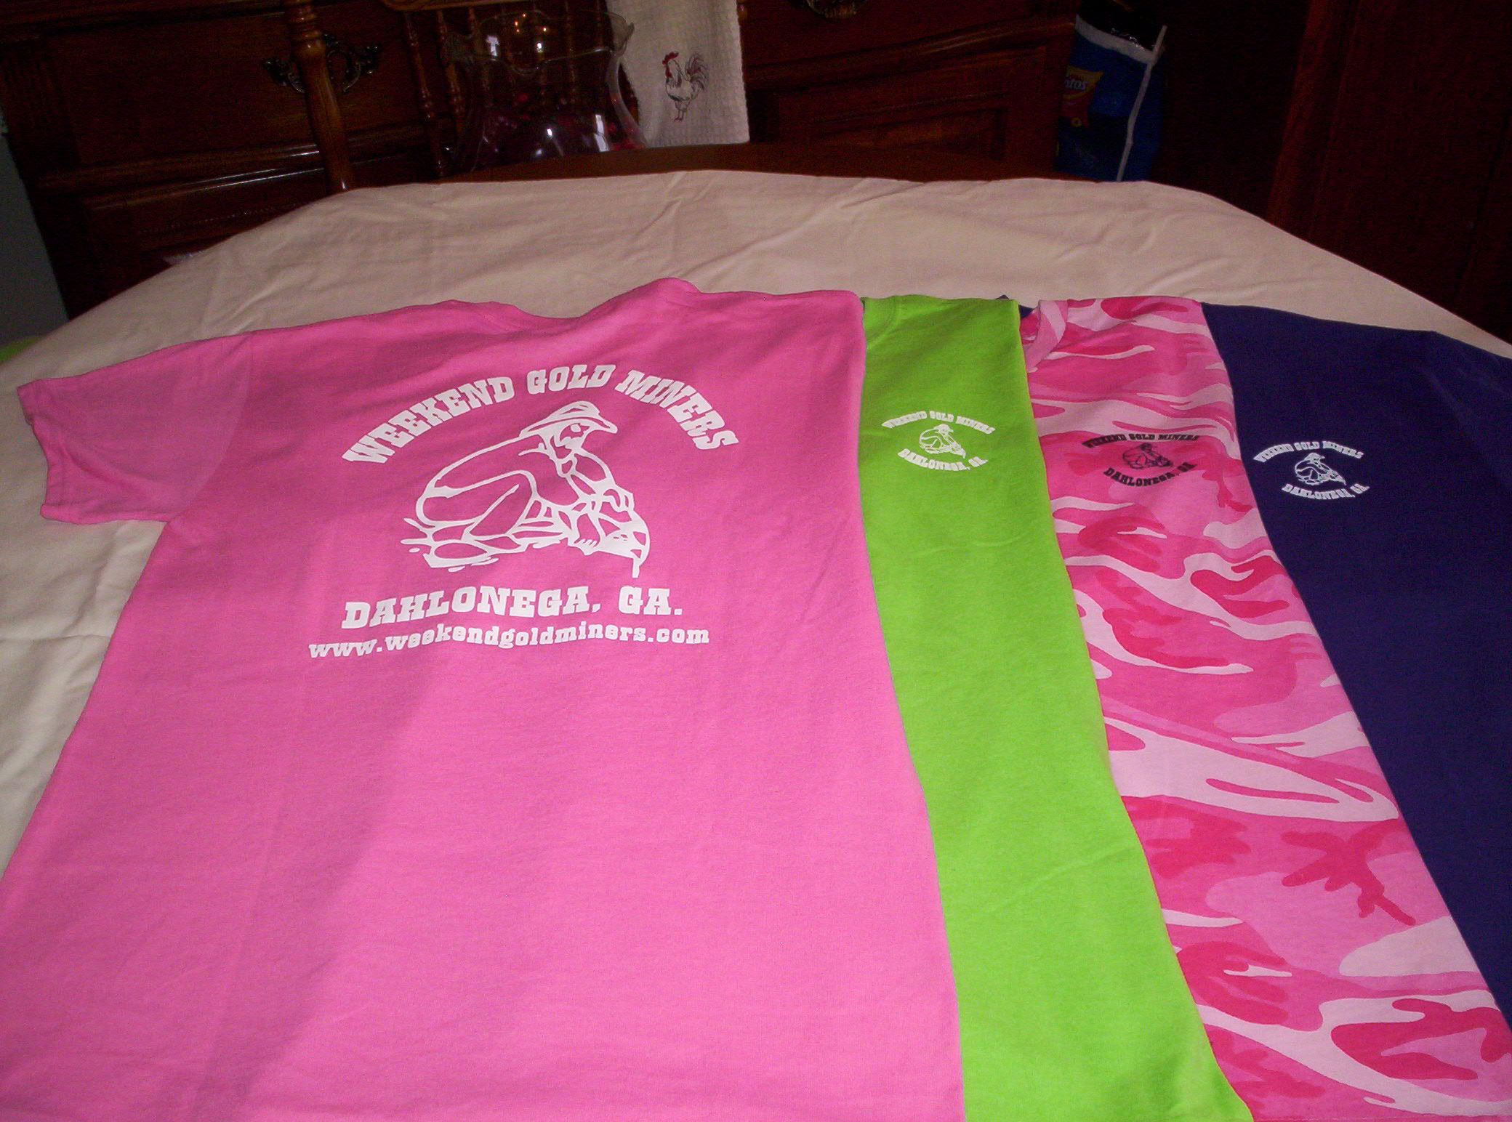

Ladies Shirt Colors: Pink, Green, Purple and Pink Camo.
Sizes: Small, Med., Large, X-Large and 2X.
Ladies shirts do not have a pocket.

Men’s Shirt Colors: Black, Tan, Grey, Hunter Green, Camo
Sizes: Small, Med., Large, X-Large, 2X.
Camo shirts do not have a pocket.

STANDING RULES
- No use of alcohol on Association outings.
- Smoking will not be permitted at Association meetings or activities unless held in the open air.
- Members are expected to adhere to the Association’s Code of Ethics while prospecting or mining
- Members are expected to conduct themselves at all times in accordance with the laws of the land and reasonable moral behavior
- Violation of Standing Rules will result in disciplinary action as determined by the Executive Board of Directors
- The President, Vice-President or their appointed spokesperson(s) are the only people authorized to speak on behalf of the WEGM
- Regular monthly meetings will be held on the first Saturday of each month at a scheduled time as stated in the club newsletter and website
- Fun must be had by all

WEEKEND GOLD MINERS PROSPECTING CLUB, INC.
GENERAL MEETING – August 6th,2022

Vice President Barbara Lawson call the General meeting to order Aug 6th 2022, General meeting to order. Welcome all members to the meeting.

Birthdays for August New member # 1940 Theresa Fenelon #2533 Bill Quick #0859 Robert Sample # 1900 Nancy Healy HAPPY BIRTHDAY … Anniversary; Randall and Dana Cowart 1yr, Prayers for # 0858 James Stefanko and Robert Russell Families as they have passed away …. Brenda Shed, she is in hospital with a broken hip.

Motion to approve minutes of August meeting as printed in the newsletter. Mark Nesbitt #2854 made motion to approve. #3615 Randall Cowart seconded the motion. All in favor, motion passed and carried.

Treasurer report given by Rodney Lung in absence of Ann Nemeth for July 2022.
Beg Bal…. ………...$ 27649.47
Income……………. $ 8127.22
Disbursed…………. $ 6557.24
End Bal……………... $ 29,219.45
Savings account…$15,895.99

#2845 Terry Newman made motion to approve treasure report, #2854 Mark Nesbitt seconded. All in favor, motion passed and carried.

Membership Report: Rodney Lung gave August 2022 report as follows.
New members 5
New members YTD 38
Transfers 02 @ $30.00 each
Last number issued #3697
Total new membership fees $500.00
Logo items $40.00
KEY $10.00 Total Collected $610.00

#2854 Mark Nesbitt made motion to accept the August membership report. #3615 Randall Cowart second. All in favor, motion passed and carried.

OLD BUISNESS.
Picnic; #2845 Terry Wilman volunteered to cook the meat for the picnic. It will be potluck members are asked to bring a covered dish or something to share with. Celeste Wilkerson has volunteered to oversee the picnic.

August 27th will be cleanup day & repair day at Turner at 10am. #3216 Lee Dewitt has donated enough metal to do one of the frames. Should anyone else have any metal to donate it would be appreciated. Metal roof last and save the club the cost of replacing the canopies every couple years.

Silver rounds: these are given out with the red tickets. In the newsletter it was stated that we could get 2021 silver eagles,24 of them for $479.52 This was a bogus ad. #2610 Ray Sparks did find Walking Liberty rounds 1oz if we buy 20 can be purchased at $25.32 plus $19.45 shipping or ½ rounds at $14.25 shipping $7.97. Membership voted for ½ oz at $500.00 for 40 coins, free shipping

NEW BUISNESS
Special meeting: the meeting was turned over to the Election Chairman. Bylaw Amendment Ballots were presented to the membership. Meeting ballots and mail in ballots were counted. All results are included at end of this newsletter.

#2533 Bill Quick made motion to adjourn August general Meeting. #2854 Mark Nesbitt seconded the motion. Meeting adjourned.

Next Meeting: Sept 3rd at Turner for annual picnic
Board meeting 12:00pm
General meeting 3:00pm

Prepared by Heidi Lung WEGM Secretary

ELECTION RESULTS

BYLAW CHANGES

ARTICILE ll Section 1
AMENDED: Management shall be vested in the members acting through the board of Directors and control of this organization.
In Meeting votes For- 17 Against -2 Mail in votes For -7 Mail in Against- 1
Total 24 For 3 Against

ARTICILE V, Section 1, Paragraph:
AMENDED: The entire management and business of the club will be vested in the Board of Directors elected from among the members and shall be elected at the Annual November Meeting
In Meeting votes For 19 Against -0 Mail in Votes For -7 Mail in Against- 1
Total Votes For 26 Against - 1

ARTICILE Vl, Section 1, Paragraph D
AMENDED: The membership Director and Newsletter Editor shall be appointed for a term of two years,
By a majority vote present at the November meeting.
In meeting Votes For- 19 Against -0 Mail in Votes For - 7 Mail in Against – 1
Total Votes -For- 26 Against 1

ARTICILE Vl, Section 2, Paragraph C, subparagraph 2
AMENDED: With regards to the corporate insurance( liability, honesty blanket bond,etc...) Renewal of the land leases and the maintenance of the leased property, cost of which may be mor than$1000.00.,
Approval of the Board of Directors is required and approval of the majority of the voting members present at the general membership meeting. This vote must be on written ballot, with ballots being given to members in good standing with voting privileges. The Talley of the votes will be recorded in the minutes and reported to the general membership in next newsletter.
In Meeting Votes For- 18 Against-1 Mail in Votes For- 7 Mail in Against -1
Total Vote For -25 Against -2

ARTICLE Vl, Section 2, Paragraph C subparagraph 2-2
AMEMDED: The Treasurer must submit, to the Board of Directors, a proposed budget by the meeting prior to the annual meeting
In Meeting Votes For-19 Against -0 Mail In Votes For-7 Mail In Votes Against- 1
Total Vote For- 26 Against-1

ARTICILE Vl, Section 2 Paragraph C ,subparagraph 2-2a
AMENDED: The Board must present the proposed budget to the membership at the annual meeting.
In Meeting vote For- 19 Against-0 Mail in votes For-7 Mail in Votes against-1
Total Votes For-26 Against- 1

ARTICILE Vl, Section 2 Paragraph 2-4
AMENDED: Club financial record must be examined prior to the Annual meeting” once every three years by a registered CPA.
In Meeting Votes For -16 Against -2 MAIL IN VOTES FOR-6 MAIL IN AGAINST -2
TOTAL VOTES FOR- 22 AGAINST-4

ARTICILE Vll, Section 1 Paragraph A
AMENDED: The Annual Meeting will be held in November. Board of Directors shall be granted the power to move annual meeting should it be necessary based on the vote of the membership present at the October meeting at the meeting
IN MEETING VOTES FOR-19 AGAINST-0 MAIL IN VOTES FOR- 7 MAIL IN VOTES AGAINST- 1
TOTAL VOTES FOR- 26 AGAINST 1

ARTICILE Vll, Section 4, Paragraph G subparagraph 1
AMENDED: Upon the beginning of the election portion of the annual November Membership Meeting, the President shall turn the meeting over to the Chairman of the Election Committee. The Chairman of the Election Committee shall preside over the meeting until all ballots have been cast. The Chairman will return control of the meeting back to the President. Once the ballots have been counted, the President will announce the final results.
IN MEETING VOTE FOR-19 AGAINST-0 MAIL IN VOTES FOR-7 MAIL IN VOTES AGAINST-1
TOTAL VOTES FOR- 26 AGAINST-1

ARTICILE Vll, Section 4, Paragraph G subparagraph 13
AMENDED: Newly elected Officers and Directors will assume their duties on the first meeting of the next calendar year

IN MEETING VOTE; FOR- 19 AGAINST-0 MAIL IN VOTES FOR-7 MAIL IN AGAINST- 1
TOTAL VOTES FOR- 26 AGAINST-1
BOARD ELECTION:

Introduction of Members running for office. William Quick for Vice President, Board of directors Randall Cowart, Robert Samples. Robert Sannuti not present. At this time the membership was asked for new volunteers or nominations for open positions. Barbara Lawson was nominated for her current position of Vice President . Nominated for the position of secretary were Heidi Lung and Dana Cowart. All agreed to run. #2854 Mark Nesbitt made motion to accept this nomination. Ballots were distributed to the general membership. Votes were given to Vice President Barbara for breakdown of the votes.

Office of Vice President Ballots cast at meeting Mail in Total
#2533 Bill Quick 12 0 12
#2980 Barbara Lawson 10 2 12

OFFICE OF BOARD MEMBER Ballots cast at meeting Mail in total
#3615 Randall Cowart 18 0 18
#0859 Robert Samples 16 2 18
#3641 Micheal Sannuti 3 1 4

Office of TREASURER Ballots cast at meeting Mail in Total
#3044 Ann Nemeth 22 2 24

OFFICE OF SECRETARY Ballot cast in meeting Mail in Total #3247Heidi Lung 9 1 10
#3615 Dana Cowart 6 0 6

#2533 Bill Quick withdrew his name for Vice President. Welcome the returning Vice President Barbara Board members Randall Cowart & Robert Samples, Treasurer Ann Nemeth and Secretary Heidi Lung.

